Woodland Parish Council Public Rights Of Way Audit

WPC was asked by a member of the public, at a recent meeting, to conduct a survey of all the rights of way, within it’s parish limits. An advertisement was put onto the WPC FB page with a map of the footpaths and bridleways concerned and descriptions and photographs were provided, mainly by 3 local people, of all the relevant areas and any problems found.

A summary of these issues is listed below. The PC intends to forward this information to Durham County Council Public Rights of Way department and request that action is taken to resolve the problems highlighted in this report as soon as possible.

Please see the map below for reference
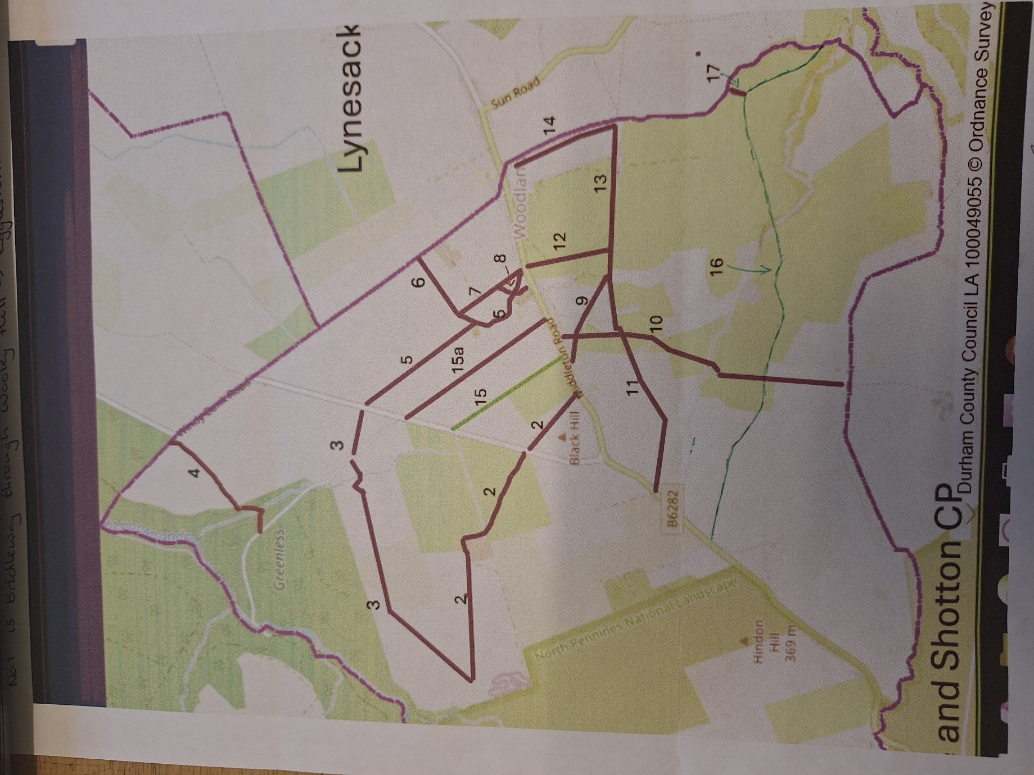

Footpath 2

This path is blocked where is crosses the road to Middleton and blocked at Job’s lodge – no access through farm and dogs loose.
Tried to walk Footpath 3 from the Blackling Hole road to the join with footpath 2 but came to the edge of the plantation which is bounded by 7" high deer fence with no gate that I could see so retraced my steps.

Footpath 3

This path doesn’t exist in the part from the back of the triangle road (Middleton Rd?) to the road to the forest. Also no signpost from the forest Rd towards Job’s Lodge. By law there should be a sign where a footpath goes off a tarmac road..

Footpath 4

Windy Bank Road at Mayland Corner to Blackling Hole Road heading west northwest.

Metal post on Mayland Corner, climb over stone stile in wall next to gate, turn left to follow the fenced track to the buildings ahead. Go through green gate secured with a cow chain, go straight on past the buildings over the stone stile next to the locked gate. Follow the fence to a galvanised gate and a waymark pointing right.
*Map indicates straight on.
Turned right short distance to next gate, then turned left along the far side of fence for about 50m(back on map line), before turning diagonally right heading down the hill towards the trees just to the left of the clump of rushes. Wooden stile in fence BEWARE STILE WOBBLY AND VERY SLIPPERY. Continue through trees to join FE red bike track “The Big ‘Un” at waymark. Turn left, then cross the beck with stepping stones, before heading right handed up the obvious track, then left after 30m to join the Blackling Hole Road at the wooden finger post.
Footpath 5

Middleton Road to Triangle Road heading north northwest

Metal post with “Public Footpath” on Middleton Road next to eastern end of the cemetery. Stone step with a narrow metal gate into the Quarry field. Follow wall around western edge of field to clump of trees.
*Map indicates path should cross wall about 20m from the trees, but no evidence of a stile. Instead there is a gap in the wall next to the trees with a sheep hurdle barrier.*
Climbed over sheep hurdles, straight across middle of grass field to stone stile in next wall. Continue straight across next field to similar stone stile in wall. Continue straight to wall on to Triangle Road, but no stile there, walked east to gate, wooden finger post on road side by the gate, but gate locked so had to climb over.
Gate often gets wired shut as you go through next to the little forest. This gate needs to be fixed so it can be opened properly.

Footpath 6

Sign on roadside, Stone stile over wall into field. Head due west across the field and between the piles of soil/stone to the gate in the wall beyond.

Footpath 7

From the end of footpath 6 turn left through the gate and follow the track along the edge of the Quarry field, through 2 fields to join Middleton Road via a stile to the west of Black Horse Terrace, sign on roadside.

Footpath 8

This path is two short connecting bits across the Quarry field connecting footpaths 5 and 7, they are not obvious on the ground but the Quarry field is open access land so the public are entitled to use all of it as long as they are not disturbing farm stock.

Footpath 9

Start of path is at Foulsyke Farm on Middleton Road. Metal sign on roadside, path obstructed through garden of farmhouse.
(I approached from the other end, off footpath 10. This field is grazed by horses, there are no waymarks. Crossed the field going west, past a wooden stable to a galvanised gate, beyond the gate is another small grass paddock with a wooden gate on to a drive. Path not clear.)
Heading East, from the junction with footpath 10, go through a small wooden gate and straight across the next paddock. There is another wooden gate in the wall. Cross the track to House and Holme, go through a narrow wooden pedestrian gate next to a galvanised gate. Follow grass path between electric fencing to metal kissing gate.
Cross this field with donkeys and poultry diagonally to the far corner of the ruined barn to join Footpath 11.
Access blocked, no access from Rd to where it crosses path 10

Footpath 10
Start to the west of Bracken Ridge, Middleton Road. Metal post on road side, stone stile over wall with sheep hurdle gate behind. Go straight ahead, over wooden stile into field grazed by horses. The map indicates the path goes straight ahead, but the stile into the next paddock is to your left in the corner of the wall and fence. I kept to the edge of the following field, the map indicates a route more in the middle of the field. Stile next to a gate into the field beyond, this is the junction with Footpath 11. Footpath 10 continues straight ahead (south) along the hedge over another solid stile, then bear right over a wide bridge over a beck. Continue diagonally across the corner to a stile in the fence line. The fence beyond has fallen over and the next stile is on the ground. Continue diagonally across the field to a gate and stile in the fence, the stone slab bridge over Foul Sike has fallen into the beck, so you need to jump the beck. Across the field to a small stile with a sheep hurdle beyond. Continue along the edge of the field to the junction with Bridleway 16. Very muddy here. Continue straight across through a gateway (galvanised gate, looks like there might have been a stile in the wall alongside but that is not there) Go straight ahead to a gate in the fence, then head down the hill to the Gaunless river. Solid concrete bridge over the river (this is the boundary of Woodland Parish), over Stone stile and straight up the hill in front. Stone stile in the wall, then head slightly right towards Hill House. Stile into farmyard, head round the left hand side of buildings to the drive way and then on to the road.
Footpath 11

OK through House and Holme Farm but blocked at the next fence – no stile and no access. Not sure about next fence along but the one after that also has an electric fence in the way that makes the stile difficult., The problems with footpath 11 are as you head west from House and Holme farm (Middleton direction)

Footpath 12
The path starts opposite Black Horse Terrace on Middleton Road, Woodland. Metal post on verge, stone steps leading to a narrow lowered fence into grass field. Follow the wall on the right due south until you hit the stoned driveway to Brass Sides. Keep straight ahead until you reach the steading. Footpath 13 is on your left, footpath 11 on your right. There is no waymark indicating Footpath 12 at this junction.
Footpath 13
This path starts at Brass Sides farm, a continuation of Footpath 11. Cross the solid wooden stile into the grass field past the north side of Brass Sides. Follow the fence and hedge, go through the metal kissing gate and alongside the shelterbelt of trees in the horse field to cross the wooden stile into the yard. Pass between the buildings, over the wooden stile into a muddy field, keep straight on heading east to the stone squeeze stile into a lane. Take the pedestrian gate into the sheep field, keeping the buildings on your right, to the stile in the wall ahead with large sign informing of bull in field. The wall is the boundary between Woodland and Lynesack parishes, footpath 13 ends here, but footpath 14 is on your left.
This path is part of the Gaunless Valley Circular Path.

Footpath 14
This path starts opposite St Mary’s church on the Village Green. Metal post on Middleton Road, pointing in to dense, tall undergrowth. (you can use the village green to go round the edge of this bit) Notice the boundary stone (Woodland/ Lynesack and Softely), a listed ‘building’ ,at the base of the corner of the wall. Follow the edge of the village green to the stone stile with handrail into the first field heading south. There is a low wooden section of fence for passage into the next field, and another such section into the field beyond. They are quite narrow, need to be flexible. Once past the boggy bit with rushes, keep to the side of the wall (on your left) until you reach footpath 13 by the stone stile into the field heading east.
This path is part of the Gaunless Valley Circular path.

Bridleway 15,

Smaller gate installed further along stone wall for access, wide enough for horses and sign in the corner needs a clean plus some vegetation clearing away.

Footpath 15a

Triangle Road to Middleton Road heading south
Wooden finger post on Triangle Road, stone stile in wall and gap in barbed wire fence. Follow broken wall and wire fence south, cattle were grazing this field summer ’25, cross stone stile with bar over in next wall, sheep grazing and boggy underfoot. Cross another stone stile before the solid and secure wooden stile in the muddy corner of the wall and thorn hedge. Thorn recently cut back. Continue along wall past windmill, over another wooden stile, past pigs and orchard over another wooden stile ( top step a bit slippery, attach chicken wire?), on the gravel path between Ridgeway House and No1 Paradise Cottages to the metal post on Middleton Road.

Bridleway 16
Wooden Finger post at roadside opposite entrance to Pike Stone on Middleton Road. Tarmac track heading east. Gate 1 – it swings but has dropped on the catch side so needs 2 hands to lift, open and close the gate.
Gate 2 – galvanised with faded waymark, no catch. The gate swings out and up, not easy to handle. Gate 3 – is at the junction with footpath 10, very muddy bit, gate ok.
The waymark sign on the gatepost is misleading, it indicates the route of the footpath (10) is through the gate and then turn left, instead the footpath is on the western side of the hedge.
Gate 4 swings and has a stile alongside it. Very muddy gateway.
The wooden bridge over Foul Sike is solid but slippery when wet, the bridlegate (5) beyond has an extended handle making it easier to open.
Gate 6 also has an extended handle but needs a second hand to pull the gate to open. The ladder stile next to the gate is rotten.
Gate 7 steel gate with extended handle, has to be pulled /pushed to release from the tight catch. Gate has dropped a bit. Continue to next gate where there is the junction with Footpath 17 (heads off to the left alongside the wall).
Gate 8 is wooden, swings well but rope to fasten it (slip over post) is too short.
Bear right looping in to dip, path not obvious, cattle grazing in summer, through defunct gateway, straight down towards the trees, pass between 2 old silver birches on obvious track. Over the solid bridge to a bridle gate (9) with a rope closure, this is the boundary of Woodland Parish.
Continue on path to go through gate 10, a red metal gate with a stiff sprung catch, the neighbouring stile is very slippery. Bridleway follows the fence on the left to gate 11 with a pull back catch. The path goes through Cow Close Plantation until it comes out on the roadside (Dent Lane)near the Copley Chimney. Metal finger post on roadside.

Footpath 17
Off Bridleway 16 just before the 8th gate heading east, turn left to follow wall and round corner to a stone stile down to a concrete bridge over the beck and a squeeze stile beyond. The beck is the boundary between Woodland and Lynesack parishes.

